GRAPH NEURAL NETWORK ANALYSIS FOR SCALABLE FAKE PROFILE DETECTION AND BOTNETS
Scope and Limitations
Department of Computer Science and Engineering, TKR College of Engineering & Technology
Batch A9 (CSE-A) · Academic year [ACADEMIC YEAR]
Table 1: Project team
S.No. | Student name | Roll number
1 | Bijja Naga Lakshmi | 23K91A0538
2 | Divvela Srivatshav | 23K91A0564
3 | Adumulla Durga | 23K91A0504
4 | Burugula Koushik | 23K91A0550

Project guide: Neelima
Chapter and section numbers quoted in the text (for example Chapter 8 or Section 6.2) refer to the full project report, 17.Final Document. Figures and tables in this document are numbered from 1.

1. SCOPE

1.1 In scope
• Building one social graph from public data and a seeded generator, with accounts as nodes and interactions (ties) as undirected edges.
• Engineering 23 node features from profile metadata, posting behaviour, temporal pattern and interaction frequency.
• Training and comparing GCN, GAT and GraphSAGE against a feature-only baseline on one stratified split, with three seeds.
• Scoring every account, explaining the score and showing the account's neighbourhood.
• Detecting coordinated clusters with Louvain over embeddings and scoring them against the injected botnets.
• Evaluation with accuracy, precision, recall, F1, ROC-AUC and PR-AUC, confusion matrices, a threshold sweep, an error analysis and a feature-group ablation.
• A scalability sweep of training and inference time on CPU up to 36,264 accounts.
• A moderator queue with logged decisions and retraining; an analyst role that can only read.
• A local web application with an API, a database and a demonstration login, run on one Windows computer.

1.2 Out of scope
• Collecting data from any live platform, or any use of real users' personal data.
• Text and linguistic features of posts (behavioural NLP is named in the batch abstract but is not implemented).
• Dynamic or temporal graph models; the graph is one static snapshot.
• Structural features from the base paper (Prüfer sequences, minimum spanning trees, closeness and PageRank); node degree enters the models only through message passing.
• Graph sampling, mini-batch training, GPU training and distributed processing for platform-scale graphs.
• Adversarial robustness: bots that adapt to the detector were not simulated.
• Production features: single sign-on, multi-factor authentication, rate limiting, TLS, auditing, monitoring and deployment automation.
• Automatic blocking or removal of accounts: BotGraph flags and a human decides.

1.3 Users and environment
The intended users are a platform trust-and-safety team (overview, clusters), moderators (queue, decisions, retraining) and researchers (model comparison and scalability). The brief names large regional platforms such as ShareChat and Moj as the motivation; no data from them was used. All measurements were made on one machine: 12th Gen Intel Core i5-12500 (6 cores, 12 threads), 16 GB RAM, Windows 11 Pro, CPU only.

2. ASSUMPTIONS
The results depend on the following assumptions, which were made on purpose and are stated so that they can be challenged.
• Public data stands in for platform data. Real topology plus real labelled profile rows is assumed to resemble the structure and attributes of a social platform closely enough to compare architectures; it is not assumed to match any specific platform.
• Injected botnets stand in for coordination. Bots that follow each other densely (probability 0.28 per pair), share a creation window and a peak hour, and follow some real accounts are assumed to be a reasonable model of one kind of coordination.
• Camouflage sets the difficulty. Giving 40 % of botnet members and 25 % of lone spammers a genuine-looking profile, and 6 % of genuine accounts a fake-looking one, is assumed to keep the task from being solved by the profile alone.
• Labels are correct. The label of every account is taken as ground truth, apart from the deliberate camouflage; no label noise was added or measured.
• Transductive setting. The whole graph, including test accounts' features and ties, is visible during training; only training labels are used in the loss. This matches a platform scoring its own existing accounts but not scoring a new account that was never in the graph.
• Undirected, unweighted ties. Follows, likes and mentions are collapsed into one kind of tie.
• Static snapshot. Account behaviour is summarised in one set of features per account, without a timeline.
• Moderators are right. A confirm or dismiss decision is treated as the true label of every affected account; a wrong decision would be learned.
• Timings are indicative. The machine was shared with another job during the latency measurements.

3. LIMITATIONS
The limitations below are listed in order of how much they affect the reading of the results.
1. The benchmark is easier in structure than a real platform. The ablation trains GraphSAGE on a single feature, the logarithm of an account's number of ties, and obtains F1 0.965, above the model with all 23 features (0.942); the no-graph model on the same single feature scores 0.338. The injected botnets and lone spammers have a distinctive local pattern of ties, and message passing over degrees alone nearly solves the task. The headline F1 of 0.939 therefore describes this benchmark and should not be read as accuracy on a real platform, and the graph's lift over the baseline (+11.2 points) is genuine for this data but partly produced by how the botnets were injected.
2. Half of the attribute signal is synthetic. The temporal and interaction features are generated by the seeded script. They are the most valuable attribute group: removing the temporal group drops the baseline from 0.822 to 0.515 and GraphSAGE from 0.942 to 0.840. Posting behaviour adds nothing (GraphSAGE 0.946 without it), because the Twitter bot label carries almost no signal.
3. Botnets are injected and seeded. Recovery of 8 of 8 botnets measures how well the method finds this kind of coordination, a known-answer test; it says nothing about the recall of real botnets, whose members need not be densely tied or share a peak hour.
4. Profile rows and posting rows are not about the same people. They are combined by resampling, which keeps realistic value ranges but not the real correlations between them.
5. Lone spammers are the weak spot. On the test split GraphSAGE caught all 82 botnet members (the baseline 64) but only 23 of 32 lone spammers (the baseline 26); all nine missed accounts are lone spammers with only 4 to 8 ties (median 7 ties against 20 for the fakes that were caught). Without a coordinated neighbourhood the graph has little to add.
6. One split and three seeds. No cross-validation and no confidence interval beyond the standard deviation over three seeds; with 114 fake accounts in the test split, one account changes recall by 0.9 percentage points. GAT is the least stable (F1 from 0.877 to 0.922 across seeds) and is not deterministic between runs.
7. Confusion matrices are for one seed. The stored confusion matrices and ROC curves belong to seed 0; the tables report means over three seeds.
8. The threshold sweep is on the test split. F1 stays between 0.927 and 0.952 for every threshold from 0.30 to 0.60, so the result does not hinge on the threshold, but the sweep's maximum (0.952 at 0.40) is chosen on the test split itself and is for analysis only; the served threshold (0.5) was chosen on validation.
9. Scalability was measured on copies. Larger graphs are disjoint copies of the 4,533-account graph, which understates the cost of a well-mixed graph, and the largest (36,264 accounts) is far below a platform of millions. Full-batch training on a graph of millions of accounts would be a memory problem; sampling was not implemented.
10. Explanations are approximations. Gradient × input is a first-order attribution; it does not prove that a trait caused the score.
11. Retraining evidence is thin. The loop is demonstrated end to end, but F1 before and after a handful of demo decisions is a single-seed comparison and shows no reliable gain.
12. Security is for a demonstration. Two seeded users with a shared password, a development JWT secret fallback, no TLS, no rate limiting and no token revocation.
13. No unit-test suite. Testing consists of a 36-check end-to-end smoke test and the build-time interface checks; there is no pytest suite, load test or adversarial test.
14. Environment. The system Python on the measuring machine needed PyTorch imported before FastAPI to load (WinError 1114 otherwise); the project's own .venv, created by setup.bat, is not affected and is not shipped.
Two figures show the limits that matter most when reading the numbers. The first shows how much each group of node features contributes, which is where the synthetic and resampled parts of the data enter. The second shows what kind of fake accounts the served model misses and which of them the no-graph baseline would have caught.
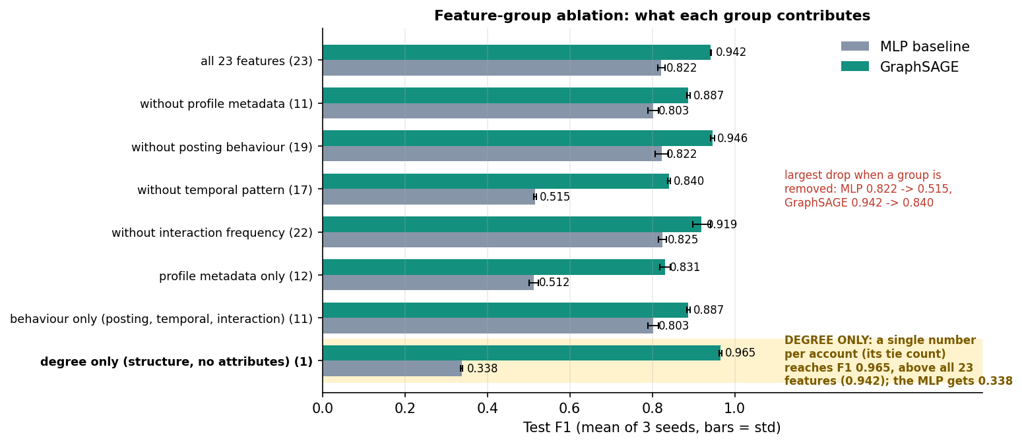
Figure 1: Test F1 of the no-graph baseline and of GraphSAGE when a feature group is removed or used alone (mean of 3 seeds).
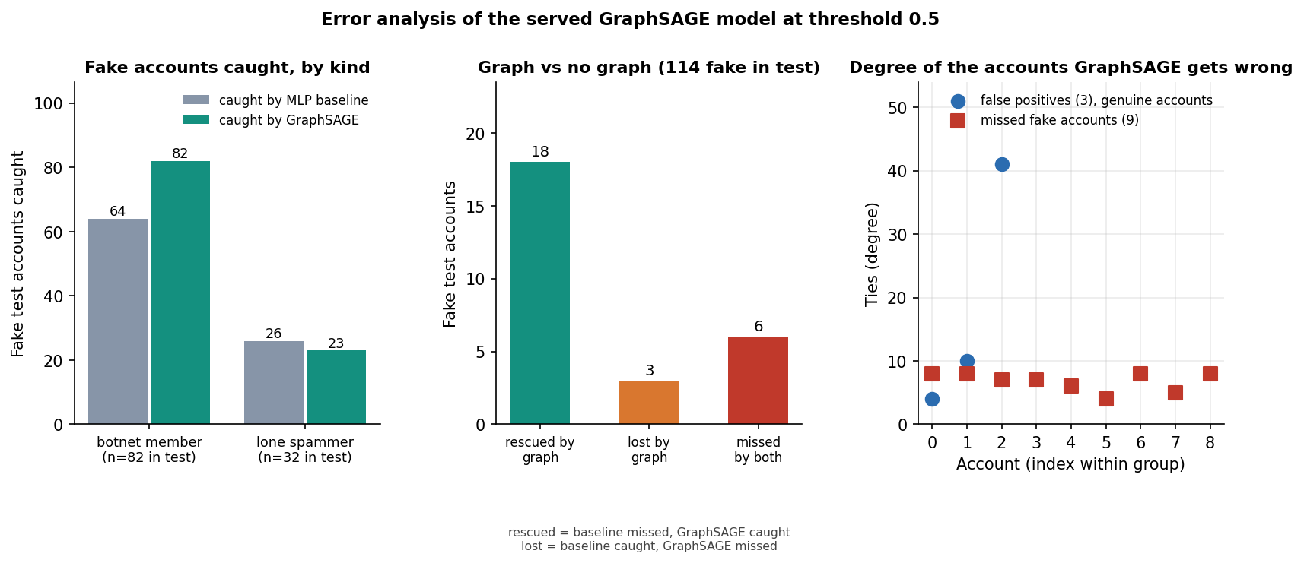
Figure 2: Missed fake accounts and false positives of the served GraphSAGE model on the test split.

4. WHAT WAS NOT MEASURED
The following were not measured, and no figure for them appears in any document.
• Performance on real, independently labelled botnets or on a benchmark such as TwiBot-22.
• Cross-validation, repeated random splits, and significance tests between architectures.
• Robustness to label noise, to missing ties and to an adversary that adds ties or copies profiles.
• A direct numerical comparison with the base paper, RABot or HW-GNN on a shared dataset.
• The contribution of individual features inside a group; only whole groups were ablated.
• Accuracy on accounts that were absent from the graph at training time (inductive use).
• Memory use, and training or inference on graphs larger than 36,264 accounts; GPU timing.
• Behaviour under many simultaneous users; only single-client latency was measured.
• Gain from moderator feedback on real decisions; only the mechanism was tested.
• Usability with real moderators; the interface was checked by script at three screen widths in light and dark themes, not by a user study.

